Courses can be modified and combined. Hybrid courses that are agency specific to the type of missions and workflow can also be quoted. Onboarding class is designed to help companies quote organizations with initial training on equipment purchased and basic flight instruction.
Course | Item Name/Description | Pricing
Intro Public Safety UAS Course (Onboarding Class) | Course is designed to train personnel on new hardware purchases and Intro to UAS. Class designed to help new teams to meet the FAA regs as well as develop an effective UAS unit. 2 -Day Class. 3rd day can be added for advanced scenarios please add 1000.00 for 3rd day. Class size up to 7 people. | 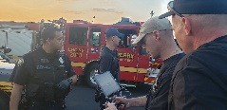Call For Quote
Part 107 Ground School | The Part 107 Ground School course is designed to prepare the participant to successfully pass the FAA Part 107 Unmanned Aircraft General test. This course will discuss the following: Federal Regulations including new regulations Basic Aerodynamic Principles National Airspace System Aeronautical Charts Basic Weather Theory Airport Operations Aeronautical Decision Making Process. 3 Day Course designed to assist agencies in getting their pilots FAA remote pilot certifications. Min Class size 7 students. | 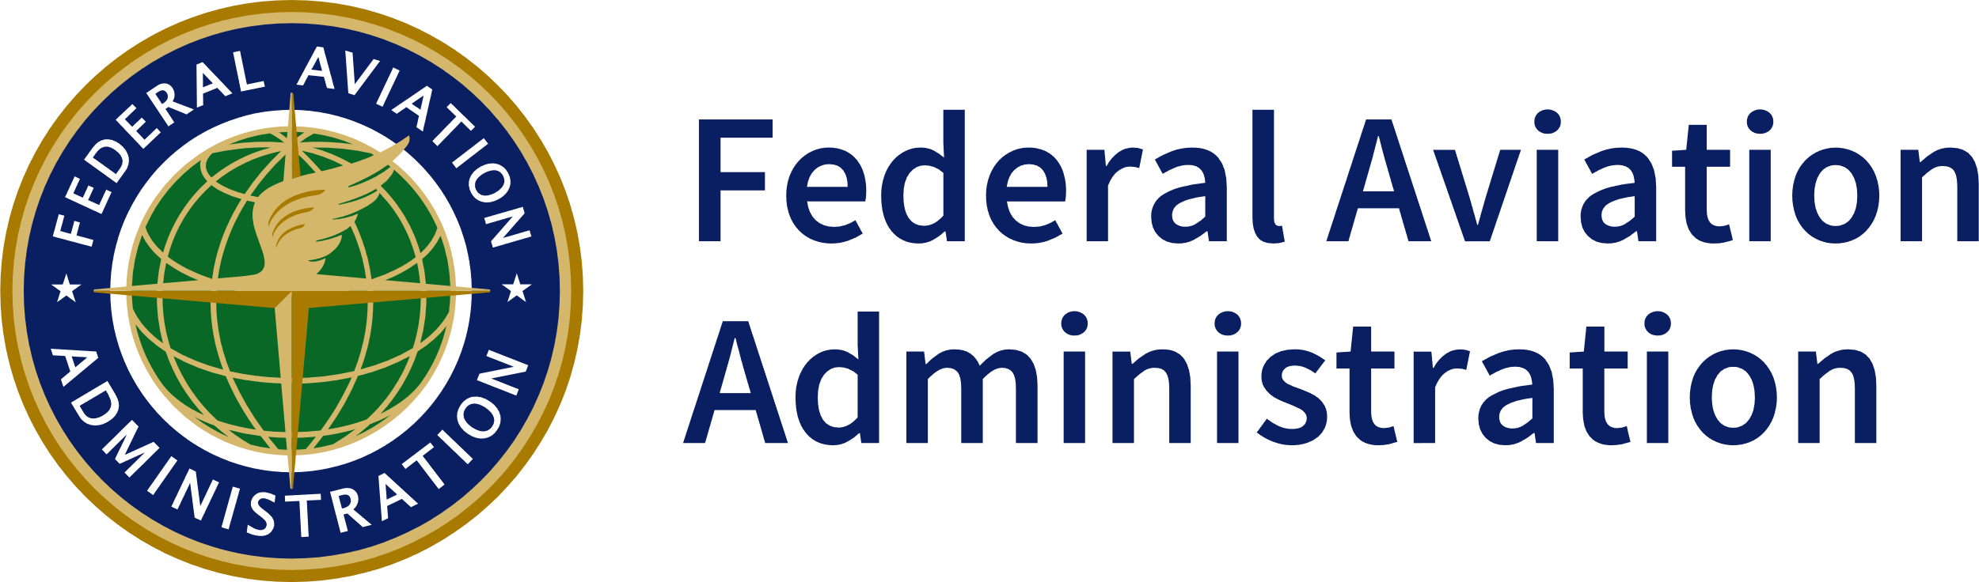Call For Quote
Night Ops, Thermal Sensors, Search and Rescue (SAR) | UAS Night Operations class is designed to prepare the participant with conducting effective UAS operations at night with an emphasis on understanding thermal sensor use and best practices. Topics of discussion will include: Challenges of UAS operations at night that impact operations Setting up a proper base of operations for night ops Understanding thermal sensors the environmental factors that impact use. Hardware platforms and choosing the right equipment. Subject detection and coordination with ground based assets for Search. 2- Day Course. Min Class size 7 Students. | 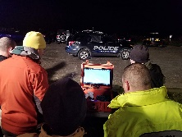Call For Quote
Crash/Crime Scene Mapping | The UAS Crash/Crime Scene Mapping Course will provide the participant how to properly create flight plans, capture data sets, and create products in the photogrammetry platform of the agency’s choice. This hands-on course will also prepare the participants to use the final products created in the class to be integrated with other 3rd party programs. Designed for traffic accident reconstruction teams. Min class size 7 students | 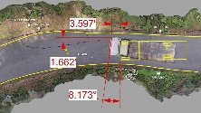Call For Quote
Tactical UAS Operations | This course is designed for the intermediate to advanced pilot. The student will learn how to fly more advanced missions such as GPS denied environments, tactical interior operations for SWAT, overwatch, high speed vehicle takedown, BVLOS flights, payload delivery, and tactical flight practices for subject search. 2- Day Class. Min 7 Students | 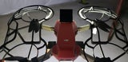Call For Quote
Basic Public Safety UAS | Students will gain a basic understanding of the current FAA regulations that affect public safety agencies and their UAS operations. Students will also receive a “crash course” in FAA Part 107 basic airmen knowledge to help prepare them for their Part 107 exam. We will discuss in detail what the Public Safety COA (Certificate Of Authorization) is and the scope of its authorization. The students will gain understanding of the different aircraft and be shown the user interface for each system. We will discuss different payload capabilities and be shown how to be proficient in operating the different sensors. The student will have a basic understanding of the ongoing maintenance needs of the different systems and will be shown how to update each system. Each student will get firsthand operational flight experience of the different systems. They will learn the basics of launching and landing and become proficient in those areas. They will also be exposed to the NIST training course which test’s pilot proficiencies in both visual acuity and vehicle control. Min -7 Students | 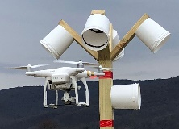Call For Quote
Disaster Response | The UAS Disaster Response course will provide best practices for responding to disasters or major incidents. Topics of discussion include: Preparation Response Coordination ICS Integration Product Development. Min Class Size 7 Students | 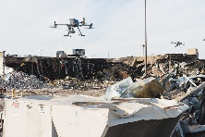Call For Quote
UAS Search and Rescue | UAS Search and Rescue Course is designed to prepare the participant to effectively conduct Search and Rescue during day and night operations. Topics of discussion will include Proper strategy and tactics for effective searches Selecting the proper search pattern and techniques Day and Night search operations Effective Thermal sensor use for SAR K9/UAS Search (Force multiplier) 2- Day Class Min class size 7 students | 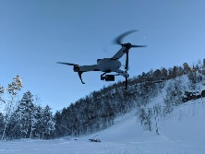Call For Quote
Counter UAS For Public Safety | Designed for agencies that are responsible for site protection at large scale events, sensitive facilities, and illegal drone related incursions. The students will learn current FAA laws and regulations and how the FAA enforces those rules. Provides emergency personnel with the knowledge and skills necessary to detect, identify, track, assess, respond, and report Unmanned Aircraft Systems (UAS) activity. Participants are presented with information on the current UAS criminal and terrorist threat, analog and electronic UAS detection techniques. This course includes performance-based field demonstrations and exercises where participants are presented with varying UAS types, their capabilities, and simulated UAS threats. 2 Day Class Min Class Size -7 | 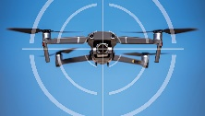Call For Quote
UAS Public Safety Supervisor | The UAS Public Safety Operations Supervisor course is designed for those in the supervisory and command role. This course will help guide supervisors to effectively know how and when to deploy UAS on your scene. It will help build a foundation through training and teach supervisors the capabilities and limitations of these systems. 3- Day Class. Min class size 5. | Call For Quote

***Custom courses can be developed for the requesting agency and new courses are also in development.***

